Challenge 1:
Challenge 2:
Challenge 3:
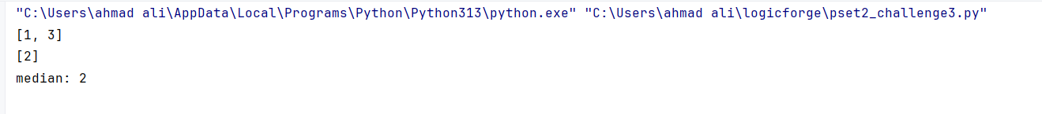
Challenge 4:
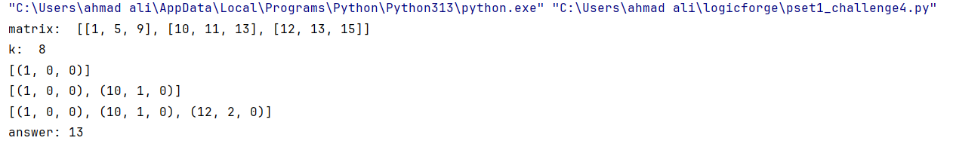
Challenge 5:
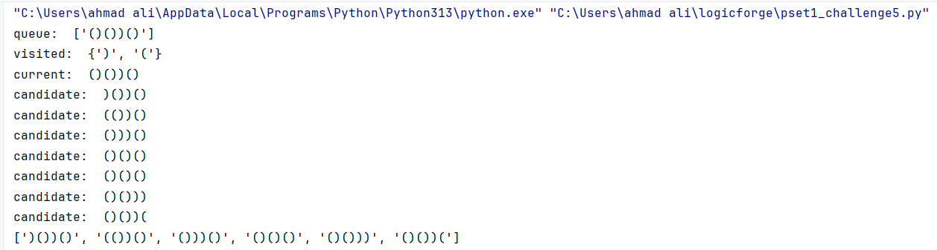
Challenge 6:
